Install docker on EC2 and explore the docker commands (docker images, containers, volumes, network)

Install docker on EC2

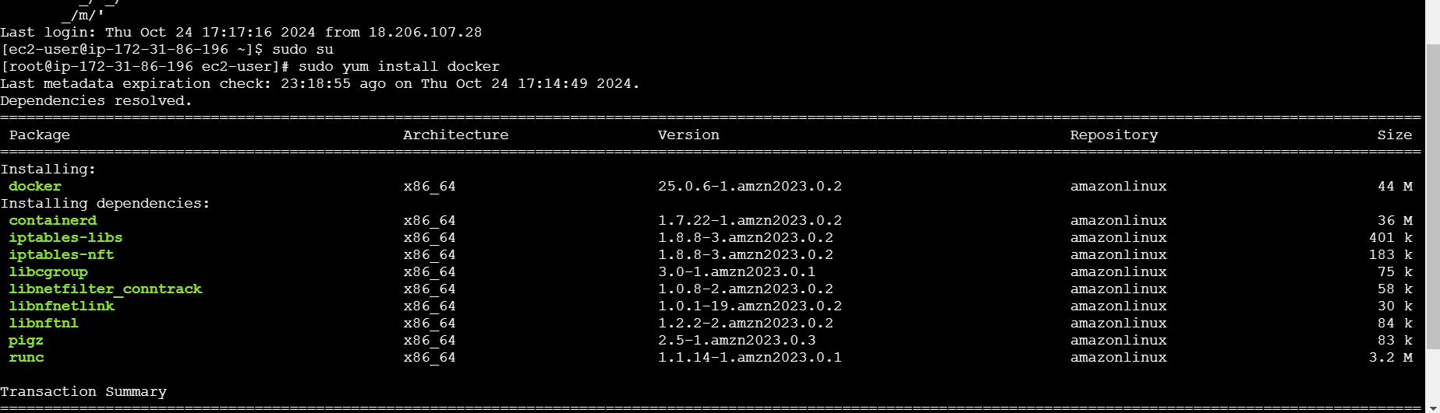

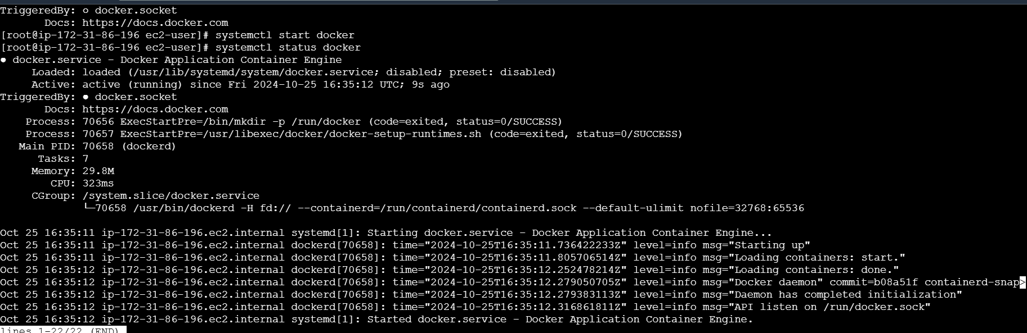

First need to bulid a docker

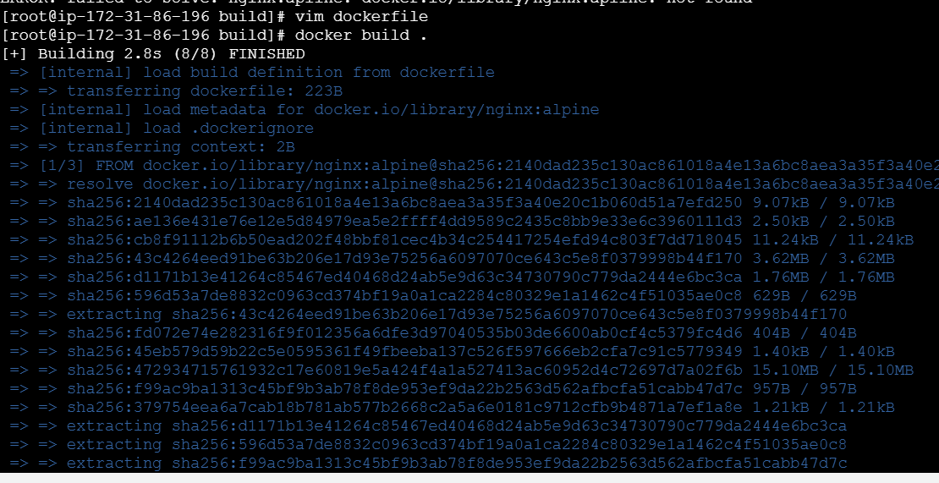

Command for docker image

Docker build –t <filename> .

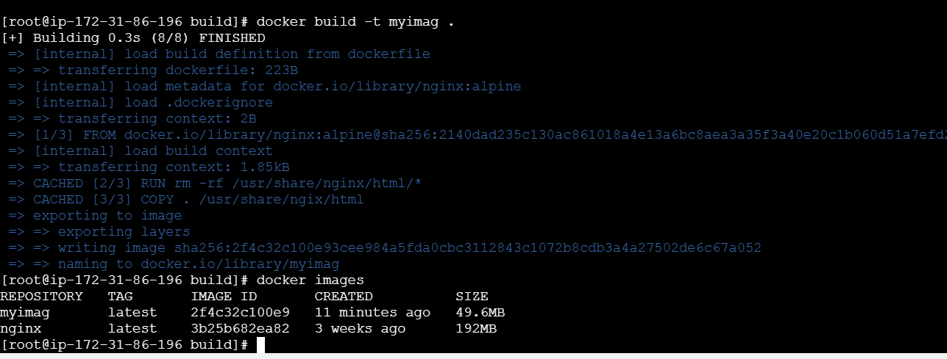

Command for docker container

Docker run –d –name container –p 8080:80 nginx:latest



Command for docker network

Docker network create <filename>

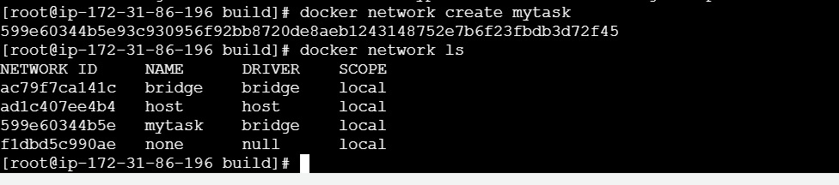

Command for docker volume

Docker volume create <filename>